|  |
| --- |
| ***Ahsanullah University of Science & Technology***  **logo.jpg**Department of Computer Science & Engineering |
| Internet Movie Database |
| Database Lab (CSE 3104) |
|  |
|  |
|  |

**Submitted By:**

1. **Nowrin Yasmin 16.01.04.001**
2. **Tajbia Hossain 16.01.04.008**
3. **Humaira Zahin Mauni 16.01.04.012**

**Introduction**

Internet movie database will be a database of world films and television series which will include cast and their respective category and ratings. Data into the database can be contributed by volunteer contributors. The database will have information about the role of an actor and will show the names of the movies they have been a part of. Additional information will also be included such as movies and TV shows adaptions from books, awards won by actors, actor management and movie production companies and actors as voice actors in audiobooks. All of these data will be interconnected allowing us to seamlessly browse through and search for data in the database.

**Design & Motivation**

The design to the database software will enable the user to access data easily without showing unnecessary information. The design layout will be simple which will allow data retrieval and data entry to be done easily.

**Platforms**

Programming Language: JAVA

Database: SQL Server

Tools: Netbeans IDE, Microsoft SQL server

**Features**

Features will be separately accessible to three types of users – Generic, Registered and Admin.

**Admin: (exclusive to this type of users only)**

* Add new movie/TV shows/actors/companies and their details into the database
* Update any data in the database

**Registered: (accessible to Admin type as well)**

* Add reviews and ratings to movies and TV shows
* Mark movies and TV shows as favorites

**Generic: (accessible to all users):**

* obtain any information from the database

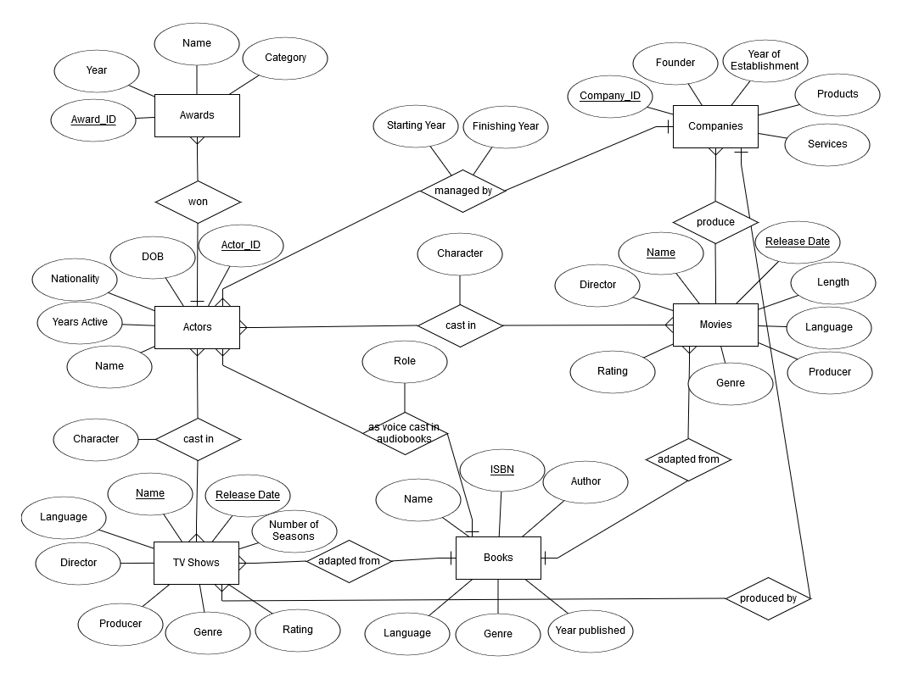**Entity Relationship Diagram**

**Design and Technical Resource**

This is a Java-based graphical user interface (GUI) application which allows a search and a display of the information. Users can run a specific query by selecting filters. The interface allows the user to search for specific information by running the queries using the MS SQL server in the back end. Generic users can search for any actor, movie and other available features through their names, id and other provided attributes. Admin users can input new data into tables and also delete previous data from the database. Administrators can also delete generic users from the database. The interface also allows creating new admin and user accounts into the database.

**Reusability**

The Internet Movie Database can be further reused to add more tables and features into the database. The interface can be reused to add more design features or improve the existing design feature my making it more user friendly.  
  
**Advantage**

The Internet Movie Database gives authoritative list of great movies. The movies and ratings are chosen by the general public rather than movie critics. Users can add new movies, actors and books into the database as soon as they are released and also remove unwanted data from the database.

**Limitations**

The Internet Movie Database has certain limitations, like data sorting. Actors and Movies are not sorted according to ratings and year. Generic users will not be able to add actors, movies and books to a favorite section. But with more implementation in the future the limitations can be overcome.

**Future Scope**

The database can be improved by implementing more queries in the future and making the interface friendlier to the user and easier to access the data. The database may also include direct video links of trailers for the movies available and a review section for the books and movies. Summaries of plots for books and movies may also be included to provide more information about a specific book or movie for the users.

**Conclusion**  
  
The Internet Movie Database has made it as easy as possible to find what we're looking for with just a few clicks, but there are a few underutilized search features that we'll want to check out as well.  Each one of these search options has a fairly extensive drop-down menu that allows us to focus on our search even further. Data can be searched using a keyword or a string. The database also allows instant viewing of the data from specific tables. The database as a whole will give us the basic data about actors, awards, movies, book adaptations and companies.